4u Demo

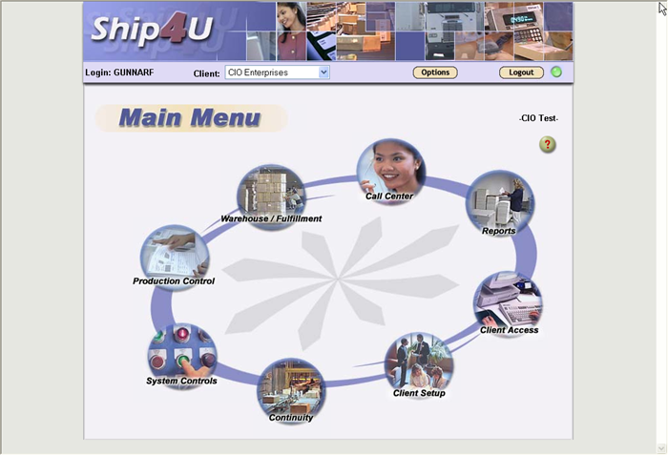

- Talk about Clients
- Talk about modules

Go to Client Set-up

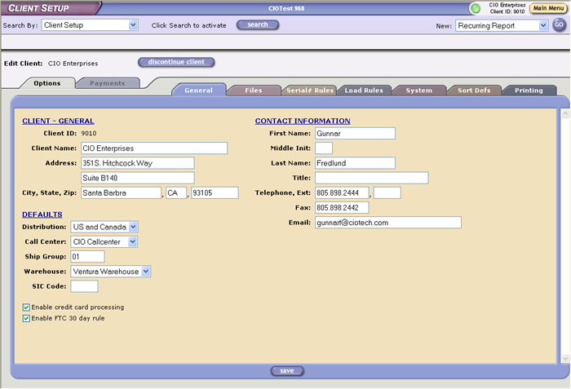

- The system lets you set-up new clients using the web interface
- Show loading rules
- Sort Defs
- Payment tab, talk about credit cards, tax and shipping calculation

Add Item

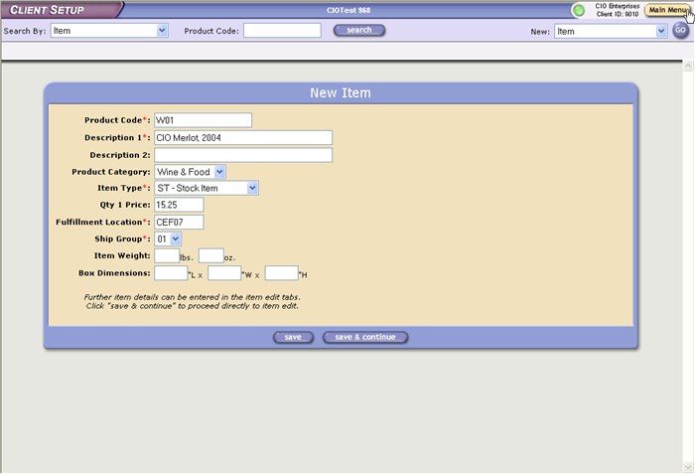

- User defined product categories
- Item Types, Stock, Kit, Promotional Kits, etc.
- Fulfillment Location
- Ship Group

Item Continued

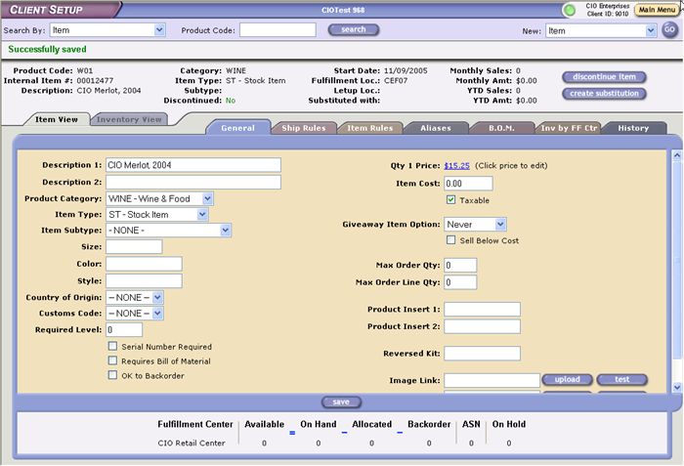

- Talk about Item Sub-type
- Country of origin, customs code
- Serial Number Required
- Price & Cost
- Inserts
- Talk about the other tabs, Ship Rules, Aliases, B.O.M Invby FF Ctr

Item Continued

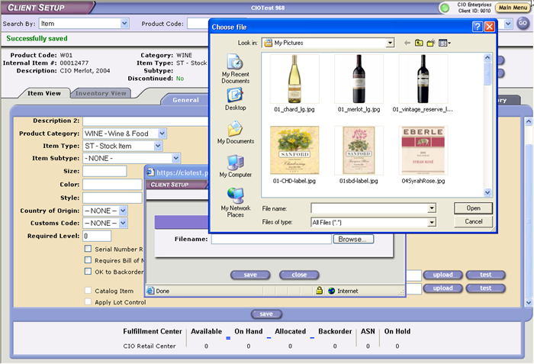

- Talk about insert of images, texts

Item Search

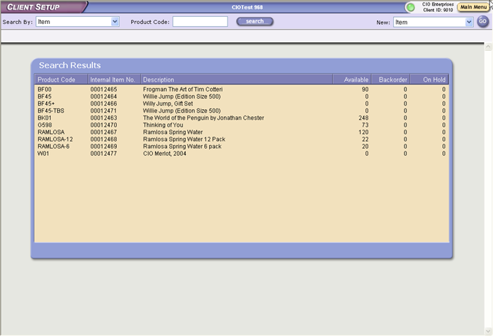

- Talk about generic searches
- Talk about available, back order and on-hold

Add Customer

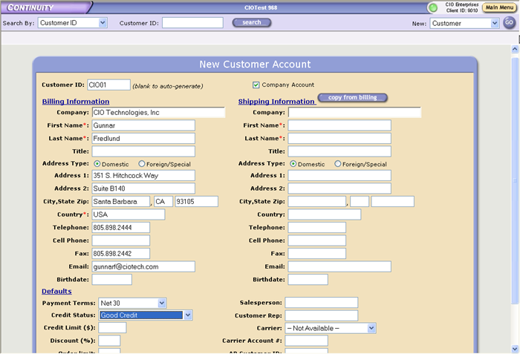

- Company or Private party
- Payment terms
- Credit status
- Copy
Customer Cont

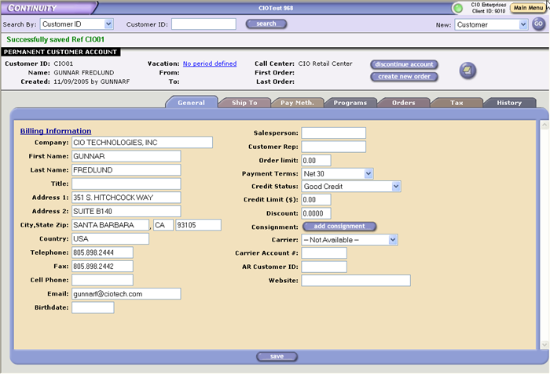

- Talk about tabs for Ship-to, Pay Method, Programs, Orders, …

Ship-to Address

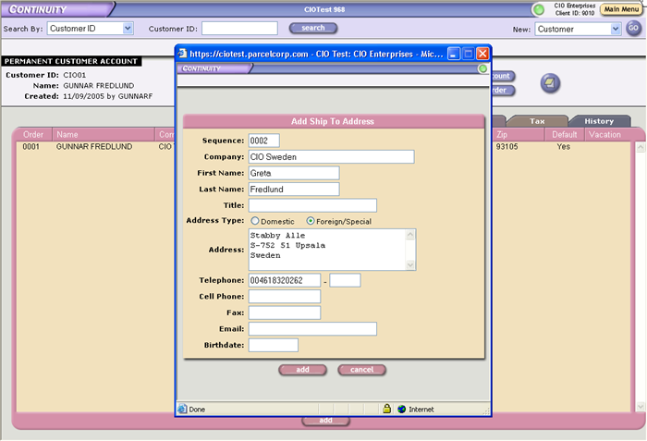

- Almost unlimited ship-to addresses
- Foreign addresses
- Default Address

Create New Order

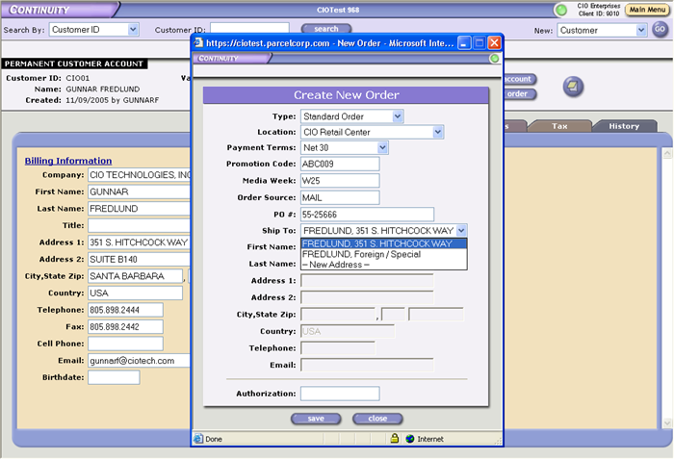

- Talk about order types
- Locations
- Payment terms
- Promo Code, Media Week and Order Source
- Purchase Order #
- Select address

Add Order Lines

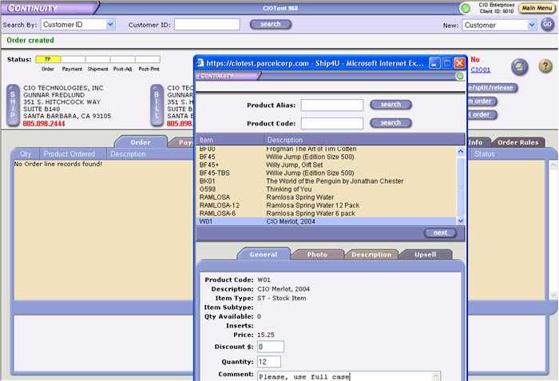

- Talk about status bar
- Talk about add line, Alias or Product code
- Choose a product
- Quantity & discount
- Notes
- Talk about changes to payment terms, addresses, ship terms, etc.

Confirm Order

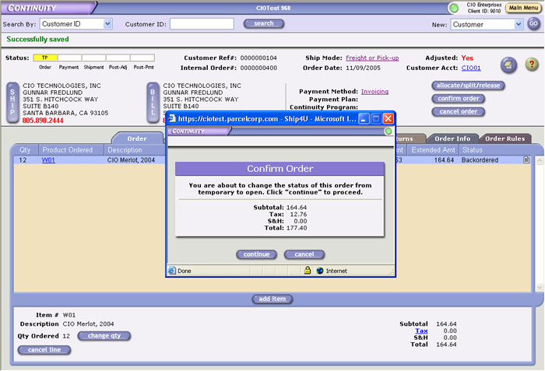

- Talk about taxes
- Talk about S& H
- Status Bar

Add a New line for a product in stock

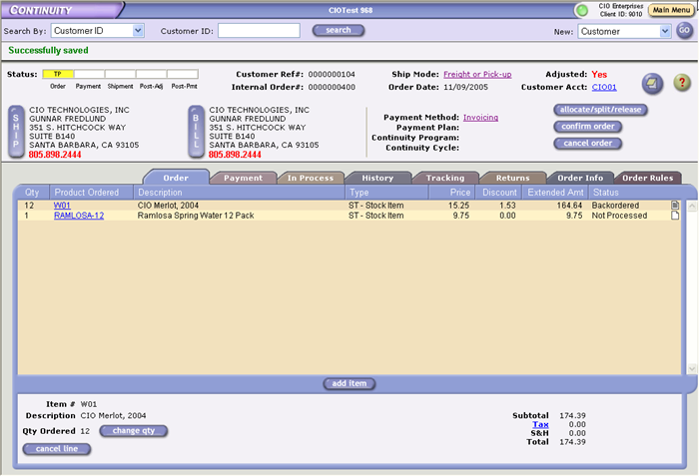

- Talk about order line status
- Tabs – show Order Info and History

Create Picks

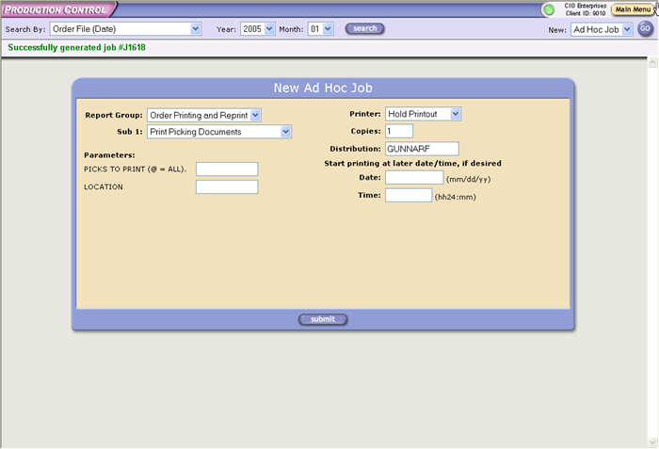

- Talk about jobs and reports
- Talk about Production control
- Talk about location

Print Picks

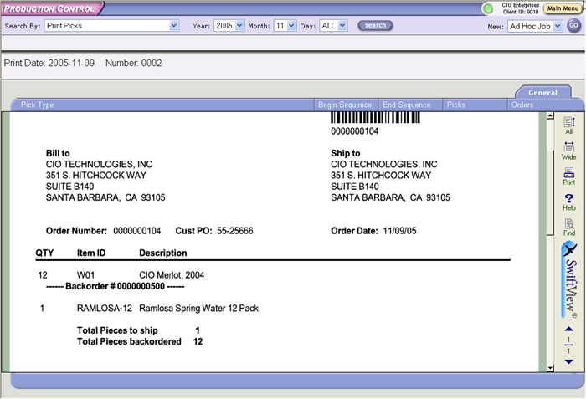

- Talk about bar codes
- Talk about back orders, etc

Printed and Backordered Orders

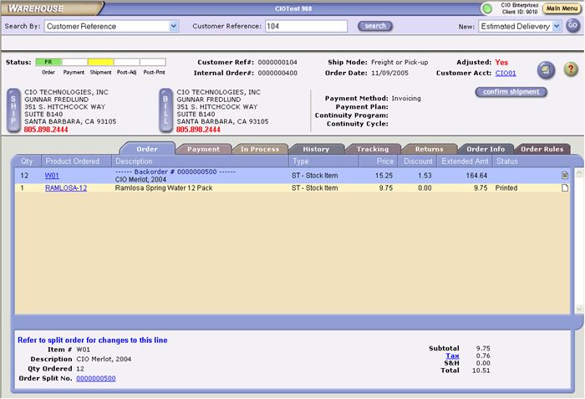

- Click on back order to show link, follow link, go back using Order-info tab
- Click on Confirm Shipment and add the data

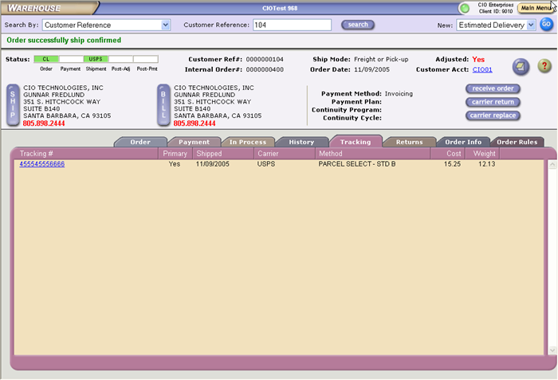

- Talk about tracking
- Cost
- Weight
- Manifest systems

Storage View

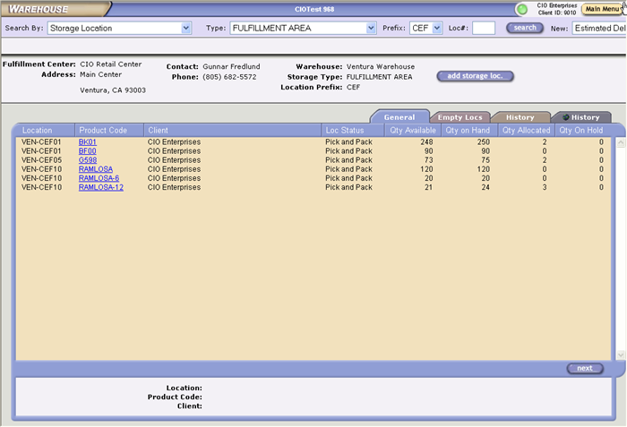

- Talk about warehouse mapping and storage types
- Talk about the snap-shot of a part of the warehouse
- Multi client
- Click on a line to show how it is stored
- Click on Empty to see where you can put things

Item Warehouse View

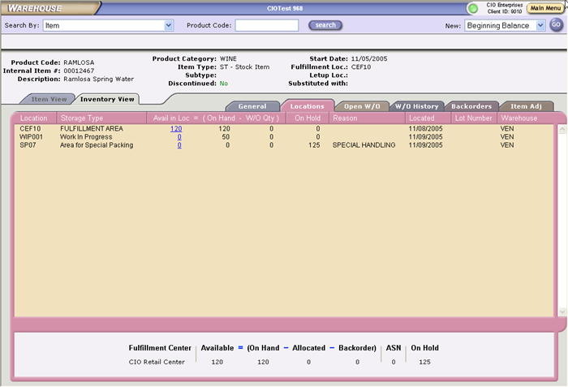

- Talk about locations
- Three types of inventory, on-hand, on-hold, work in progress
- Look at W/O History and item Adj

