Ship4U Reports

Ship4u has a large set of standard reports built into the system. The system also contains a report menu structure where the reports are gathered into groups to make navigation easier.

- Order Tracking, the group contains the reports needed to monitor the fulfillment process. The reports show printed but not shipped orders, unconfirmed temporary orders, back orders and future orders.
- Sales Statistics, these reports shows orders as soon as they are entered even before they shipped.
- Shipping Statistics and Tracking, these reports only selects shipped orders and can be used for billing purposes, tracking of shipments and to gain knowledge about the process. An interesting aspect is that clients using promotional kits and aliases often have sell one set of products but actually ships another set, the sales shows a promotional kit but the shipping report lists the components.
- Order Printing Reports, these reports are control reports monitoring the loading and pick print process.
- Payment Processing Reports, reports used mainly when Ship4u is used for payment processing. The reports show credit card and electronic check transactions, deposits, declines and financial summaries.
- Inventory Reports, the system has a set of inventory reports in html or Excel format to cover the needs of various clients
- Products, product set-up and definition
- Customers and Continuity, reporting for permanent accounts and continuity programs
- Warehouse Reports, reports regarding work orders, adjustments, etc.
- Receiving Report, these reports documents the receiving process from Advanced Ship Notification, arrival of containers and LTL freight, receiving and locating products.
- Returns and Repairs, these are specialized reports documenting customer returns and the repair process using service orders.
- Limited Edition Reports, reports handling the needs of clients with limited edition or serialized products
- System Reports, this module contains the set-up information, list of users, transactions, ship methods etc.

The reports are posted to an internal or external web-site (with client access). The format is HTML, CSV or XML format for Excel (it follows the Spreadsheet ML implementation).

1. Order Tracking

Order Tracking reports are used to control production, they include

Name | Description
Orders By Status | The main control report, it can show all orders which has not shipped, deleted orders, all orders for a period, shipped orders, etc. depending on selection
Unconfirmed Temporary Orders | control report which shows all orders still sitting in unconfirmed status
Backordered Items Report | Show summary by product or detailed back order report
Backordered Kits Report | Same report for Assembly Kits
FTC Backorder Report | A report letting you select orders which will run into FTC issues
Backorders CSV File | Creates a CSV file for mail merge of FTC notices
Future Orders Requirements | Shows inventory needed for future orders

1.1 Orders by Status
Orders by Status can be used to show orders with a variety of selections,

L – Loaded Orders, shows orders being loaded, back orders and future orders
A – Allocated, inventory allocated, selected for printing or credit card processing
P – Printed orders
T – Total, show all order for a period
X – Exceptions, shows all orders which neither has been deleted or shipped (should be run every day after ship confirmation)
D – Shows all deleted orders for a period
S – Shows all shipped orders for a period

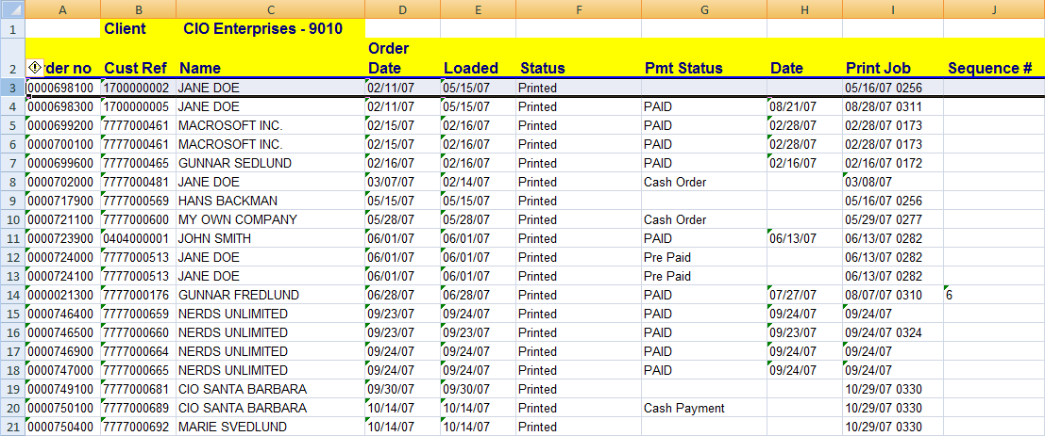

1.2 Return Report

The detailed report is shown below; it is sorted by product and has one line per back order.

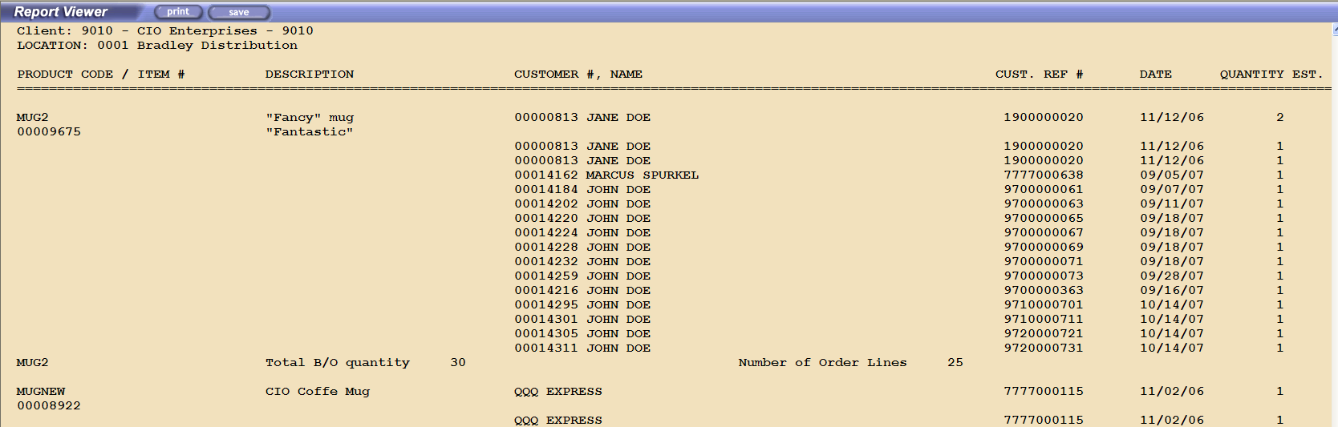

1.7 Future Orders – Requirements

Shows inventory which will be needed at a later date

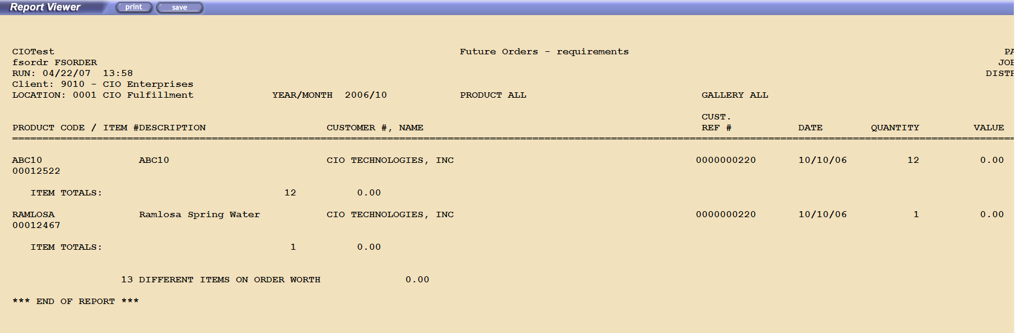

2. Sales Statistics

The sales statistics reports can be used to show sales before any product has shipped and certain reports can also be used to match reporting from in-bound call centers and ecommerce sites. These reports can be used but it is safer to use the corresponding reports for shipped orders as some orders will never be shipped (customer changes his mind or credit card gets declined).

Name | Description
Sales Summary by Loaded Date | Sales report showing statistics based on the date the order is confirmed in Ship4u
Sales Summary by Original Date | Sales statistics based on the date the customer placed the order
Invoice Summary | Summary of invoicing
Sold Products by Customer | Shows to whom a product (or all products) were sold
Sold Products Total | A sales total by product
Revenue by Source – Sales | Shows sales based on order source (web, call center, mail orders, etc.)

2.6 Revenue by Source - Sales

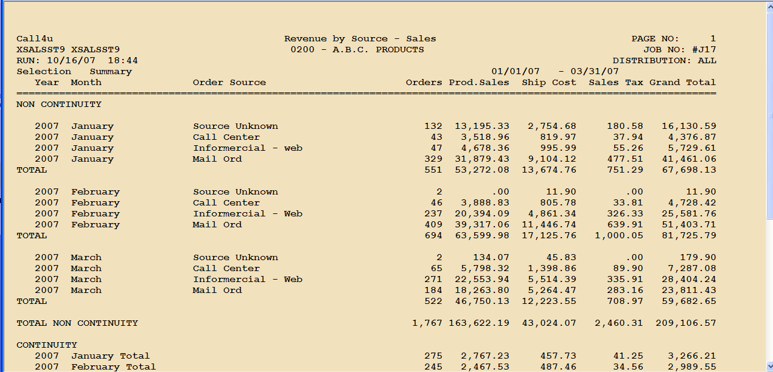

3. Shipping Statistics and Tracking

The report shows shipping statistics in summary or detail.

Name | Description
Product Shipped Total | A total per product shipped for a date range
Shipping Report by Customer | Shows to whom a product (or all products) were shipped
Shipped Products Detail | Reported by product, date and order and shows quantities shipped by order
Shipping Summary | Shows shipping and order totals in summary form
Shipping Summary, Short | Another summary format
Shipping Summary, Excel | Summary format for Excel
Order Ship Percentages Report | Percentages shipped within time periods
Shipped Products by PMT Type | Shows shipments based on payment type (Cash, Checks, Visa, Amex,…)
Revenue by Source – Shipped | Shows shipments based on order source (web, call center, mail orders, etc.)
Shipped Orders for Product Category | Shows shipment details for a single product category

3.1 Products Shipped – Total

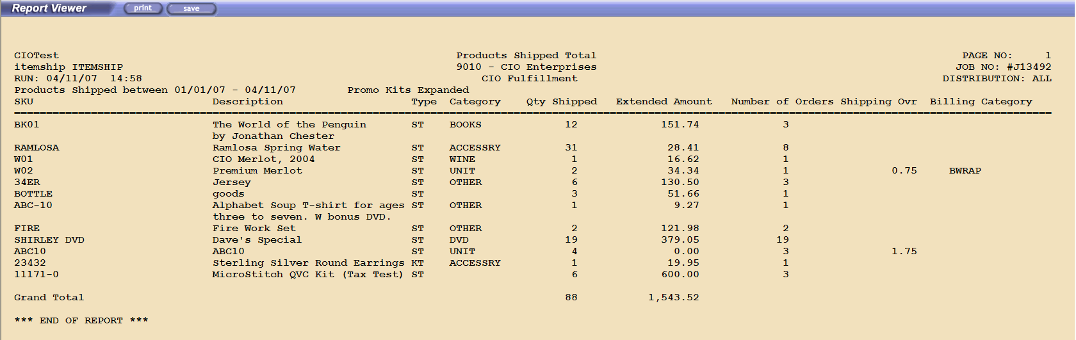

3.2 Shipped Products by Customer

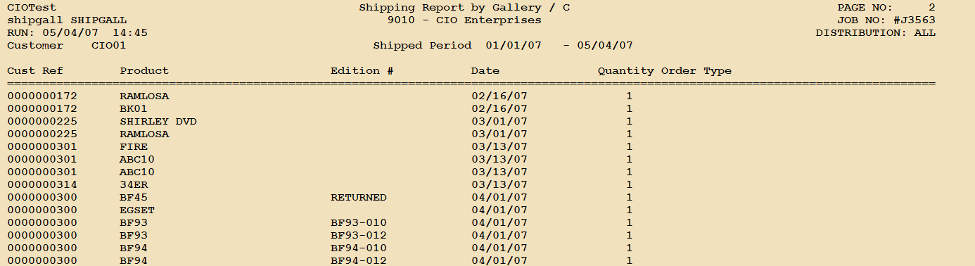

3.3 Shipped Products Detail

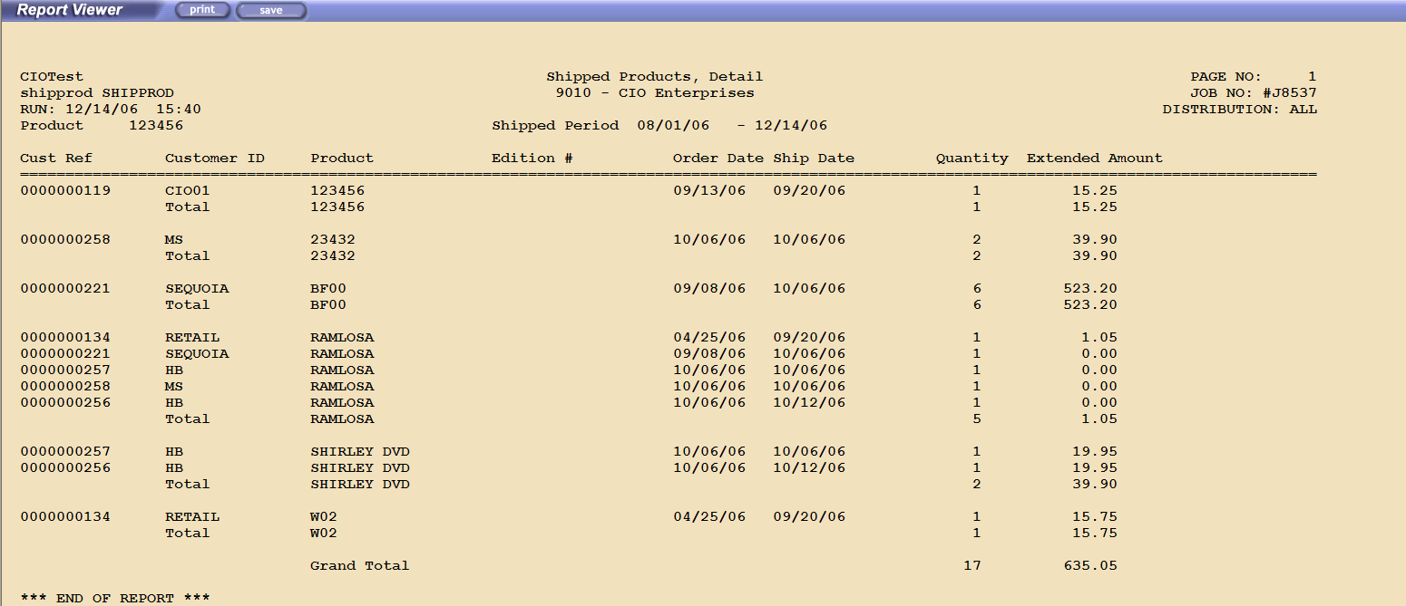

4. Order Printing Reports

The report shows shipping statistics in summary or detail.

Name | Description
Batch Load Error Report | Errors from Batch Loading
Pick Printing summary | Shows to whom a product (or all products) were shipped
Order Print summary Report | Production reports when several pick selections are used
Rejected Orders Follow-up | Shows rejected orders with current status to determine if all problems have been resolved

4.1 Batch Load error Report

The report shows rejected orders with one report per client file.

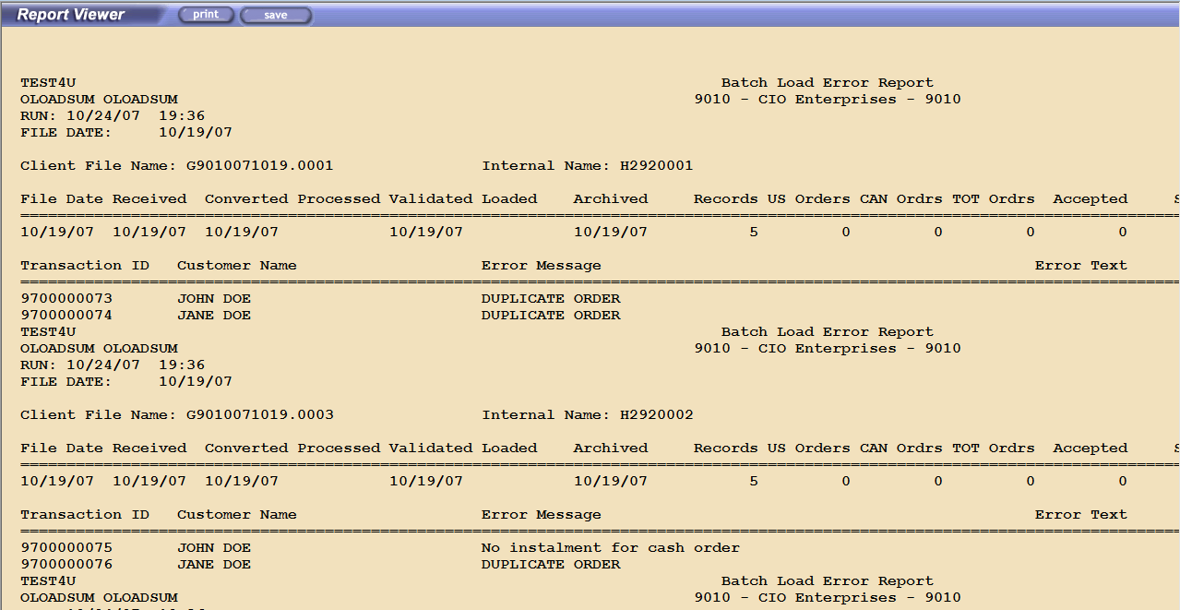

4.3 Order Print Summary Report

The reports shows each pick run and how many picks were printed by sort group.

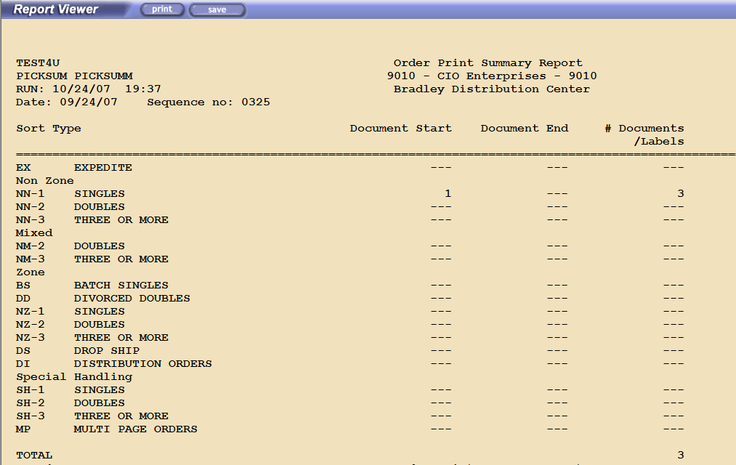

5. Payment Processing Reports

The report shows financial information when Ship4u handles credit card payments and electronic check processing

Name | Description
Daily Charge Summary | Shows charges and deposit summary
Charge Summary and Declined Orders | Charge summary and a detail report over declined charges
Fulfillment Summary Report | A snap-shot of all financial activity
Cash Order Summary | Report showing cash orders, money orders, donations and other orders paid before loaded into Ship4u
Check Refund Reports | Shows refund transactions due for orders paid outside of Ship4u
Multi-pay forecast | Shows Installments not yet due
Soft Declines | Soft Declined Orders
Hard Declines | Hard Decline Orders
Sales Tax Reporting | Sales tax summary
Refund, tax reporting | Sales Tax refunded for returns or general refunds
Returns, Replacements Control Report | Control report to assure that everyone gets their allowed refunds

5.1 Daily Charge Summary
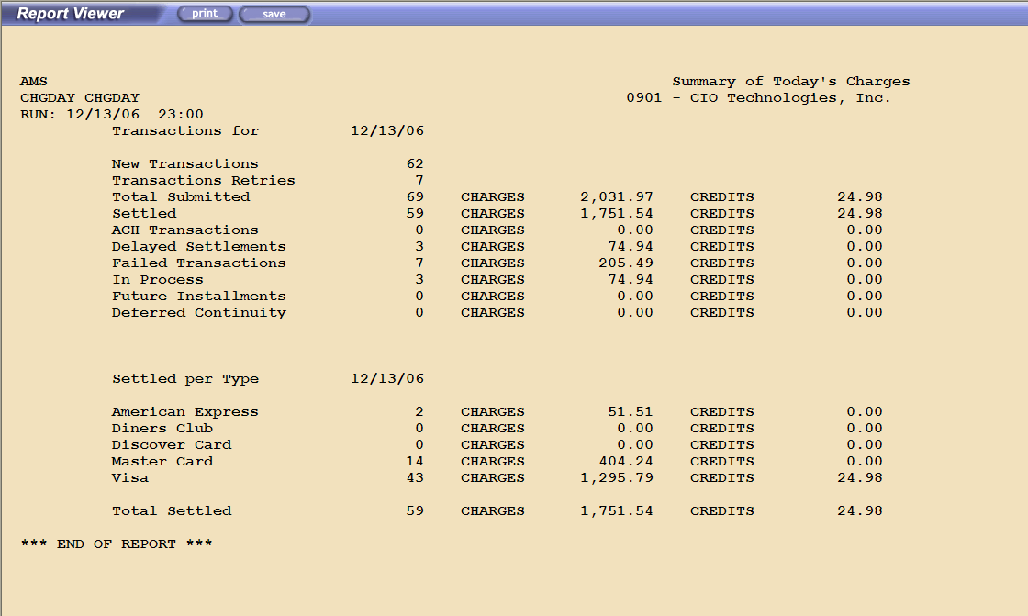

5.3 Fulfillment Summary Report
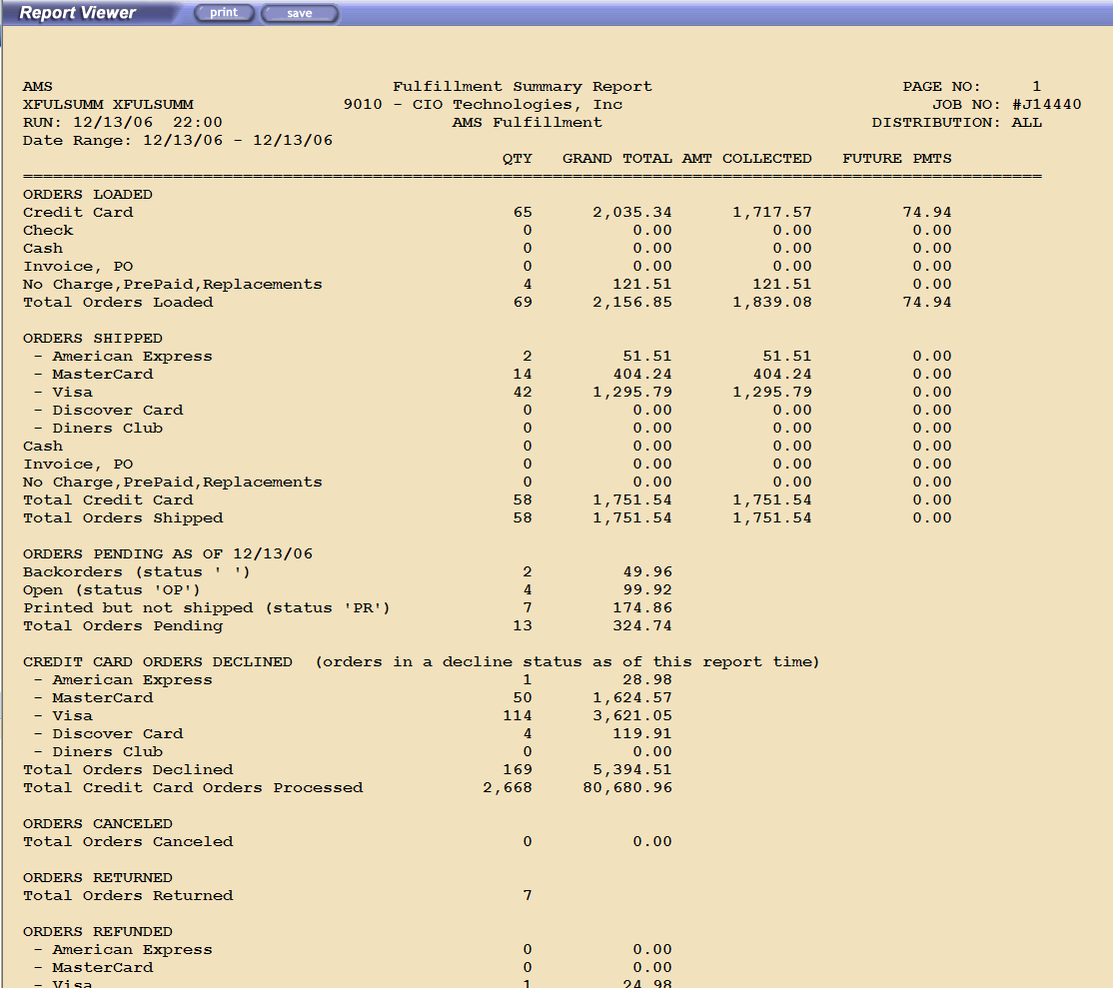

5.7 Check Refund Report

The report shows all refunds due to orders paid outside Ship4u and which has to be refunded with a check payment.

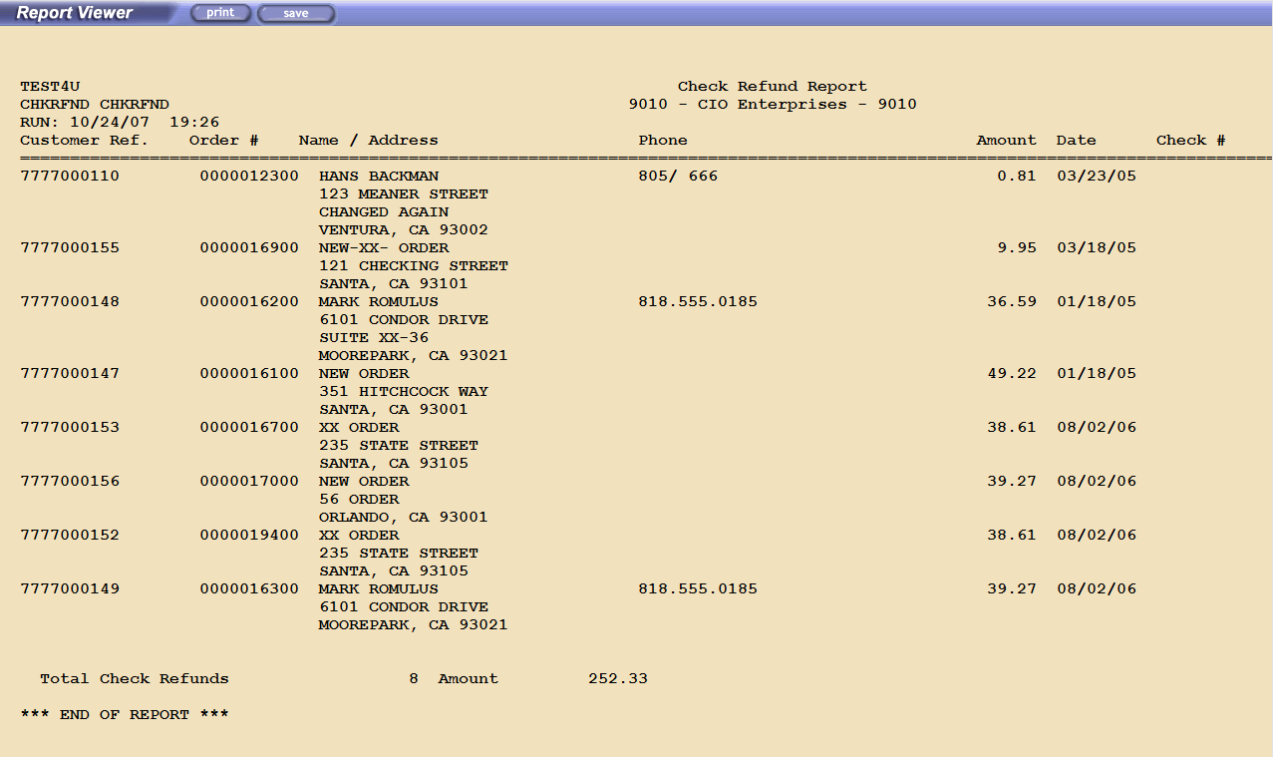

5.9 Sales Tax Reporting

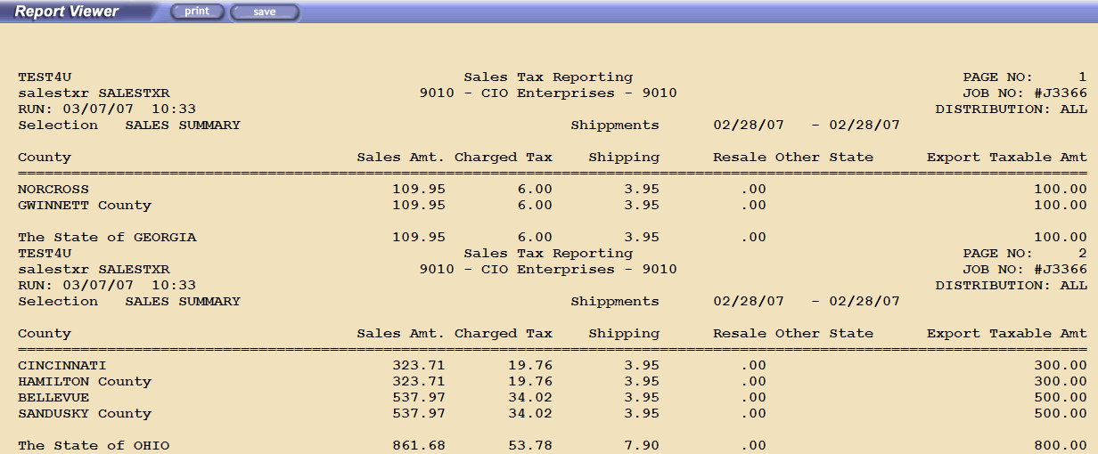

6. Inventory Reports

Ship4u has a series of reports to monitor inventory

Name | Description
Inventory Report Excel Option | Standard Inventory Report
Inventory Report-Consignment | Special report for consignment inventory
Inventory and Restock Report | Shows inventory, sales, returns and restock levels
Zon/Bin Inventory Check Report | Report handling zone-bin fulfillment
Zon/Bin Inventory Check History | Report handling zone-bin fulfillment
Inventory Report w Sales Price | Inventory and pricing
Inv Sum – OnHand/Hold/Wip | Inventory changes over time
Inv-Sum – Turn Ratios | Shows average inventory, shipped and turn ratio for a period

6.1 Inventory Report Excel Option

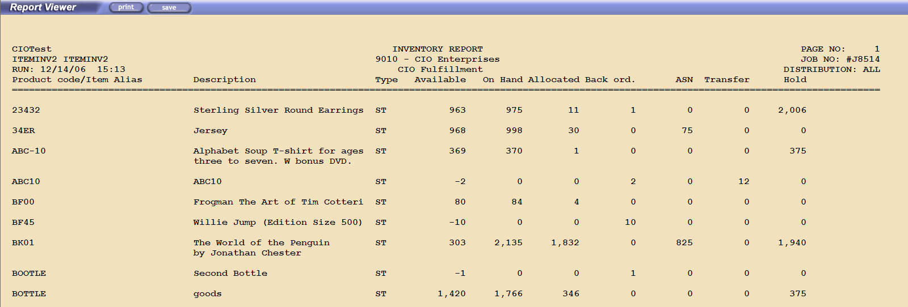

6.3 Inventory and Restock Report

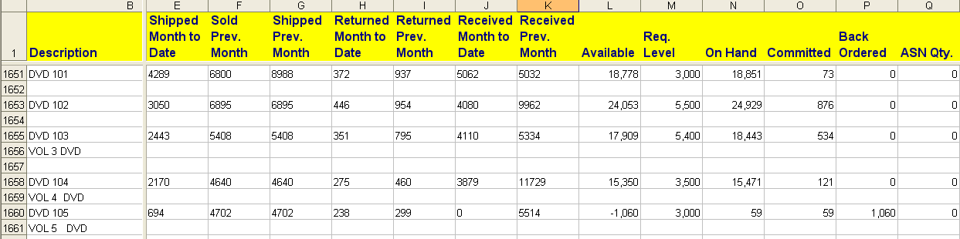

6.7 Inv Sum – OnHand/Hold/Wip

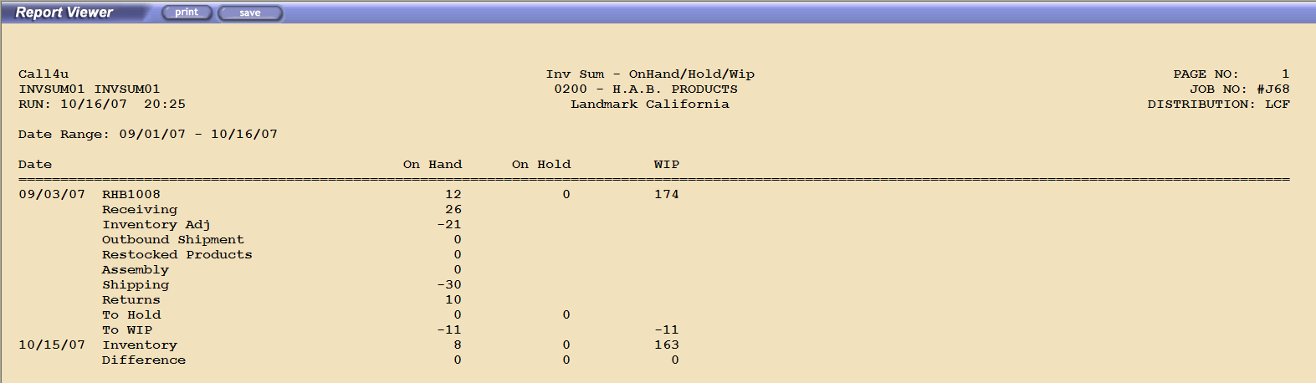

7. Product Reports

Name | Description
Item List | Standard product list
Item Alias List | Product Offers
Bill of Materials List | Shows kits and components
Price List | Product pricing
Substitution Report | Shows substitutions for backordered items
Active Substitutions | Currently active substitutions
Discontinued Products | List of retired products
Raw Product List | Dump of all fields in Excel format
Raw Alias List | Dump of all fields in Excel format
Warranty Information | Warranty and return periods for products

7.1 Item List
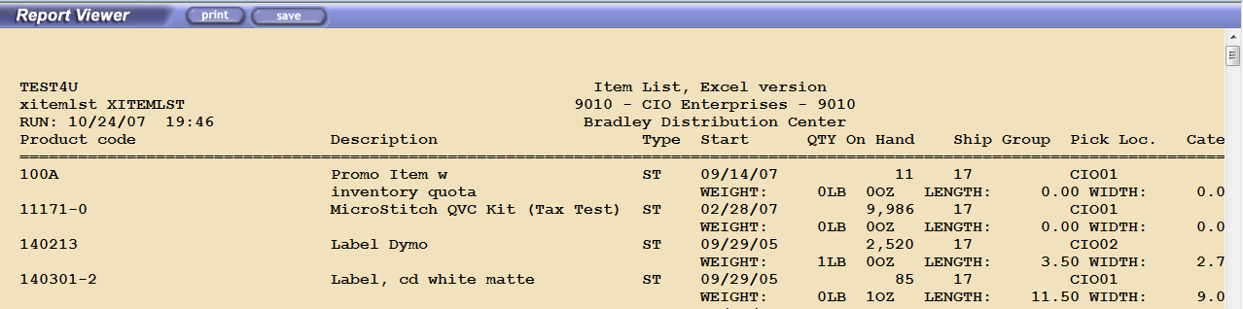

7.3 Bill of Material List

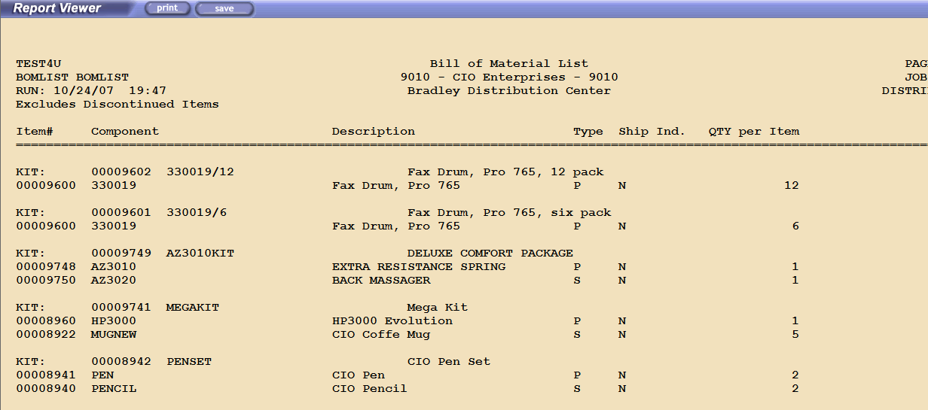

7.4 Price List

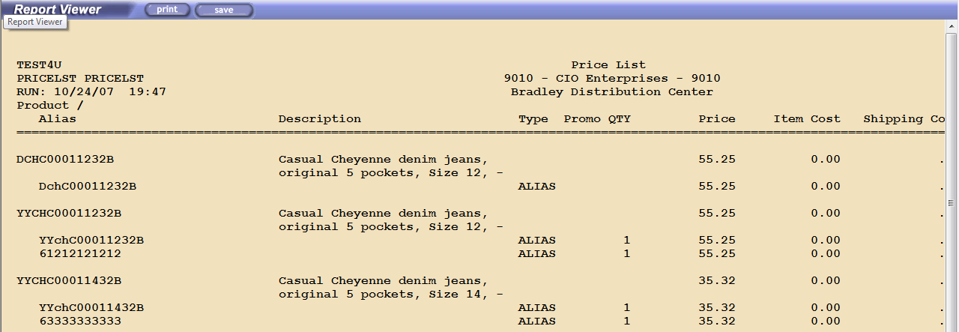

8. Customers and Continuity

Name | Description
Permanent Account List | Customer List
Continuity Report and Forecast | Continuity Summary
Bill of Materials List | Shows kits and components

8.1 Permanent Account List

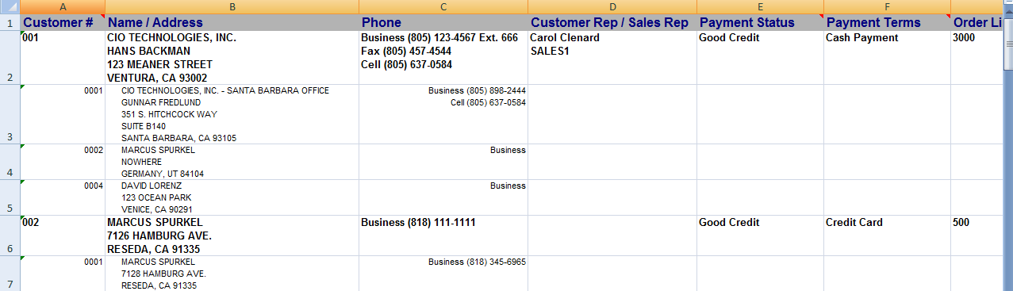
8.1 Continuity Report and Forecast

The first part of report shows how many orders you have per cycle and retention. And the second part shows how many and when the next orders will be released.

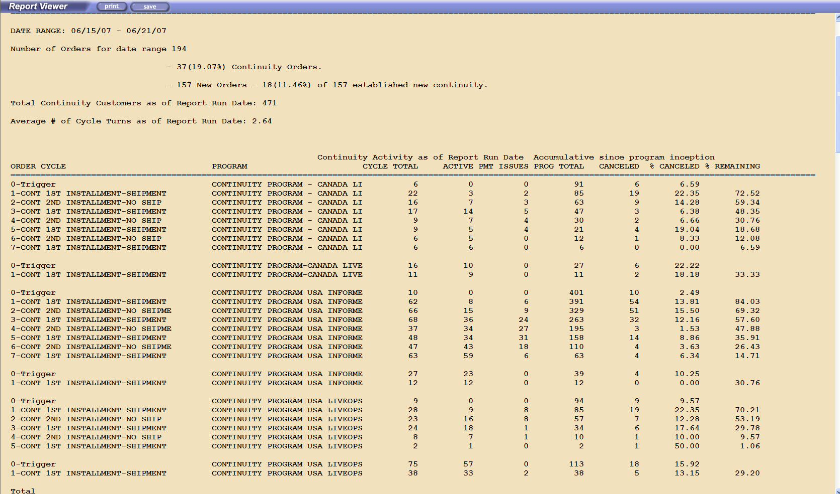

9. Warehouse Reports

Name | Description
Today’s Demand | Forecast of daily requirements
Open Work Order Report | Shows all open work orders
Work Order History | Shows work orders for a product
Price List | Product pricing
Inventory Adjustment Report | Shows all inventory adjustments for a product (or all)
Vendor Returns | Shows returns to manufacturer
Work order reprint | Reprint of open work orders

9.5 Inventory Adjustment Report

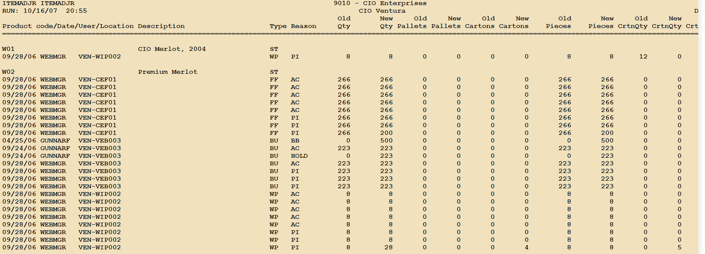

9.7 Work Order Reprint

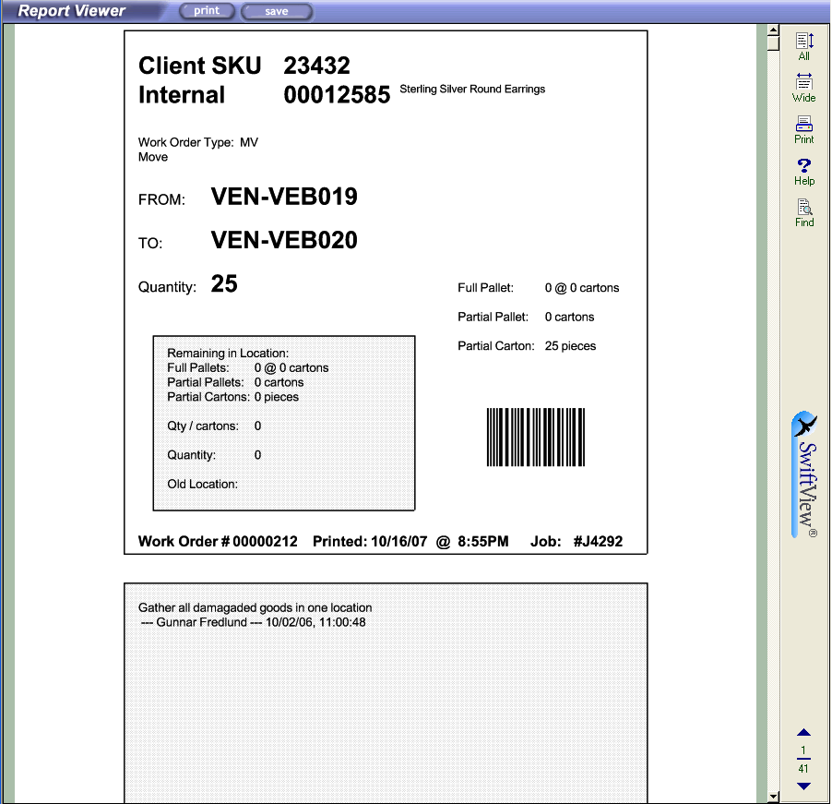

10. Receiving Reports

Name | Description
Receiving Report | Shows all received goods
Estimated Delivery Report | Shows all scheduled shipments
Container / LTL Report | Show shipment status

10.1 Receiving Report

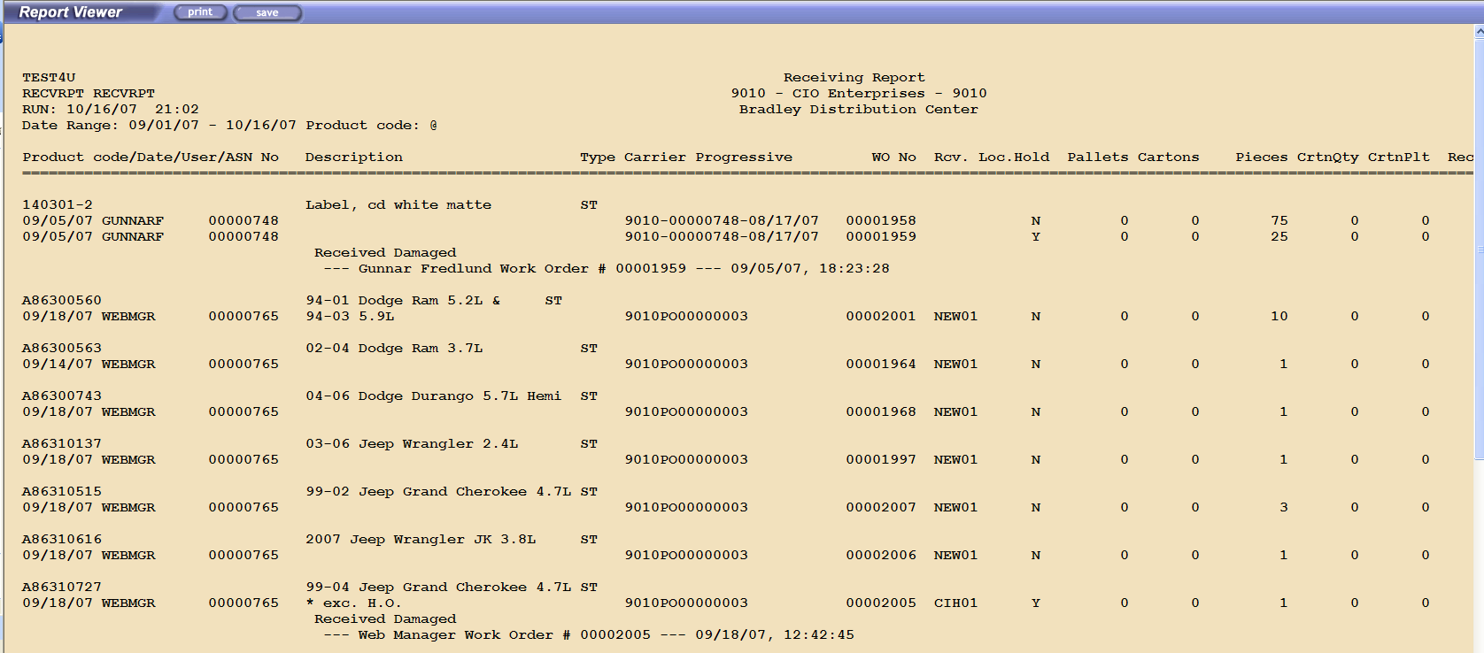

11. Returns and Repairs

Name | Description
Returns Report | Standard Return Report
Product Return Report | Shows all scheduled shipments
Return Statistics | Show shipment status
Repair Tracking Report | Tracks repairs from customer return until shipped back
Shipped Repair by Customer | Repairs per customer
CRA issued by User | Control report showing what returns the call center approved
Rate of Returns Report | Shows if aging for returns and % going through customer service

11.1 Returns Report

The first part shows all returned products

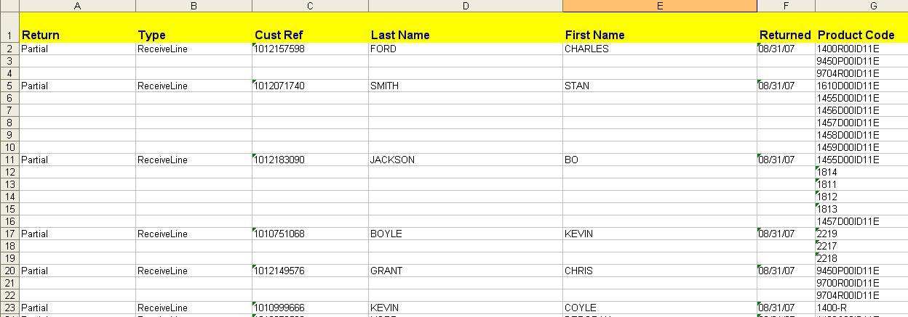

The second part shows returns based on return reason

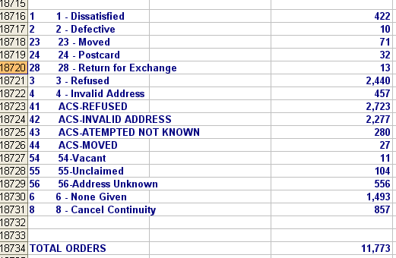

11.2 Product Return Report

The report shows a summary by product and time period with the returned products extended order amount.

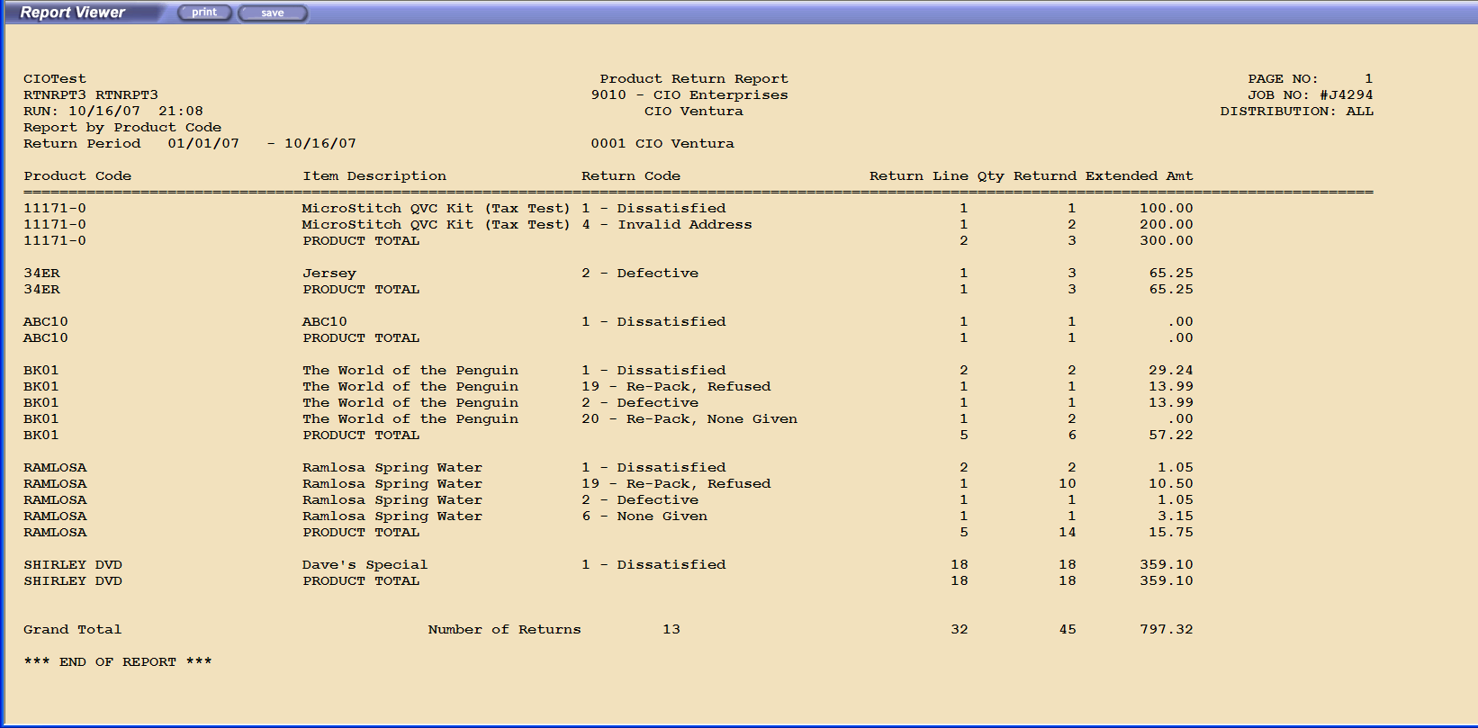

11.3 Return Statistics Report

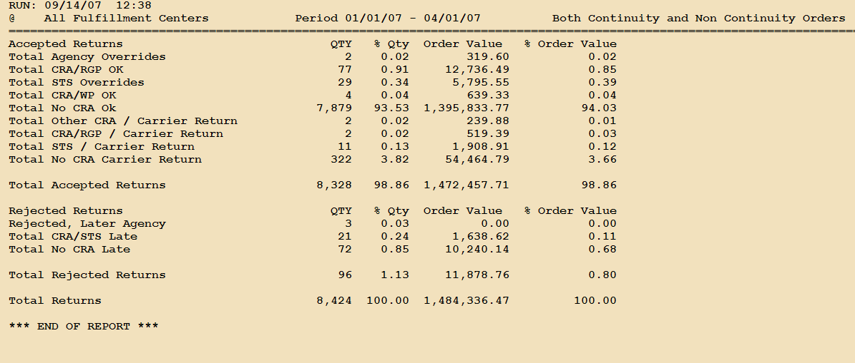

11.6 CRA’s Issued by User

The report shows who set up Credit Return Authorizations and what the reason was.

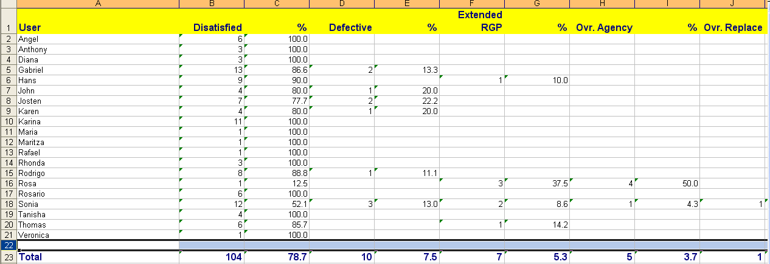

11. 7 Rate of Returns Report

The rate of returns report shows how well the customer follows the return instructions and call customer service before sending back the product. The report also shows how old the accepted returns were.

